

**UCS1711 - MOBILE APPLICATION DEVELOPMENT LAB**

**Assignment 1**

Name: Jayannthan P T

Dept: CSE ‘A’

Roll No.: 205001049

Generate a Health Insurance registration form to register the patient details under each group.

**Patient Details**

1. a. Assign a title for the registration form(TextView- textSize, textStyle , typeface)

Group1 Patient Details

1. b. Patient Name. Specify some font and colour. (use TextView, EditText-standard)
2. c. Patient Phone Number (Mobile or Landline use Checkbox)
3. d. Address (use TextView, EditText-standard)
4. e. Age (TextView, EditText)
5. f. Date of Birth (DatePicker)
6. g. Gender (RadioButton)
7. h. Marital Status (Spinner)

**Employer Details**

1. a) Patient Employer
2. b) Employment Status (full time, parttime, unemployed, retired, student, other Checkbox)

**Emergency contact Details**

1. a) Name (EditText)
2. b) Relationship (EditText)
3. c) Address (Textarea)
4. d) Phone Number (EditText- inputType, phoneNumber)

Use Submit (Button) to submit the details and display the contents. Use Reset button to clear the form.

**Additional:** Display using Table layout create an output window using OPENGL and to draw the following basic output primitives:

**Ex. No:1**

**Date:**26/8/2023

**Title of the Program:** Generate a Health Insurance registration form to register the patient details under each group

**Objective:**

The objective of the Health Insurance Android App project is to create a user-friendly application that allows users to input their personal details, employment information, and emergency contact details. The entered data is then displayed in a well-organized manner for the user's review.

**Algorithm:**

1. Create the main activity layout (**activity_main.xml**) with input fields for patient details, employment information, and emergency contact details.
2. Implement the logic to retrieve user input from the main activity, including handling radio buttons, checkboxes, and date picker.
3. Design the display data activity layout (**activity_display_data.xml**) using a **ScrollView**, **TableLayout**, and **TableRow** structure to display the entered data in a tabular format.
4. Pass the collected data from the main activity to the display data activity using an intent with extras.
5. In the display data activity, retrieve the data from the intent and populate the appropriate **TextView** elements in the layout.

**Features used:**

1. **EditText** widgets for user input.
2. **RadioGroup** and **RadioButton** widgets for gender selection.
3. **Spinner** widget for selecting marital status.
4. **CheckBox** widgets for selecting multiple options (employment status).
5. **DatePicker** widget for selecting the date of birth.
6. Passing data between activities using intents with extras.

**Source code:**

* MainActivity.java

package com.example.healthinsurance;

import androidx.appcompat.app.AppCompatActivity;

import android.content.Intent;

import android.os.Bundle;

import android.view.View;

import android.widget.ArrayAdapter;

import android.widget.Button;

import android.widget.CheckBox;

import android.widget.DatePicker;

import android.widget.EditText;

import android.widget.RadioButton;

import android.widget.RadioGroup;

import android.widget.Spinner;

import java.text.SimpleDateFormat;

import java.util.Calendar;

public class MainActivity extends AppCompatActivity {

    // Declare your view elements

    EditText patientNameEditText, addressEditText, ageEditText, employerEditText,

            emergencyNameEditText, relationshipEditText, emergencyAddressEditText,

            emergencyPhoneNumberEditText;

    RadioGroup genderRadioGroup;

    RadioButton maleRadioButton, femaleRadioButton, otherRadioButton;

    Spinner maritalStatusSpinner;

    CheckBox mobileCheckBox, landlineCheckBox, fullTimeCheckBox, partTimeCheckBox;

    DatePicker dateOfBirthDatePicker;

    Button submitButton, resetButton;

    @Override

    protected void **onCreate**(Bundle savedInstanceState) {

        super.**onCreate**(savedInstanceState);

**setContentView**(R.layout.activity_main);

        // Initialize your view elements

        patientNameEditText = **findViewById**(R.id.patientNameEditText);

        addressEditText = **findViewById**(R.id.addressEditText);

        ageEditText = **findViewById**(R.id.ageEditText);

        employerEditText = **findViewById**(R.id.employerEditText);

        emergencyNameEditText = **findViewById**(R.id.emergencyNameEditText);

        relationshipEditText = **findViewById**(R.id.relationshipEditText);

        emergencyAddressEditText = **findViewById**(R.id.emergencyAddressEditText);

        emergencyPhoneNumberEditText = **findViewById**(R.id.emergencyPhoneNumberEditText);

        genderRadioGroup = **findViewById**(R.id.genderRadioGroup);

        maleRadioButton = **findViewById**(R.id.maleRadioButton);

        femaleRadioButton = **findViewById**(R.id.femaleRadioButton);

        otherRadioButton = **findViewById**(R.id.otherRadioButton);

        mobileCheckBox = **findViewById**(R.id.mobileCheckBox);

        landlineCheckBox = **findViewById**(R.id.landlineCheckBox);

        fullTimeCheckBox = **findViewById**(R.id.fullTimeCheckBox);

        partTimeCheckBox = **findViewById**(R.id.partTimeCheckBox);

        dateOfBirthDatePicker = **findViewById**(R.id.dateOfBirthDatePicker);

        submitButton = **findViewById**(R.id.submitButton);

        resetButton = **findViewById**(R.id.resetButton);

        // Outside the OnClickListener block

        Spinner maritalStatusSpinner = **findViewById**(R.id.displayMaritalStatusSpinner);

        ArrayAdapter<CharSequence> adapter = ArrayAdapter.**createFromResource**(

                MainActivity.this, R.array.marital_status_options, android.R.layout.simple_spinner_item);

        adapter.**setDropDownViewResource**(android.R.layout.simple_spinner_dropdown_item);

        maritalStatusSpinner.**setAdapter**(adapter);

        // Inside the OnClickListener block

        submitButton.**setOnClickListener**(new View.**OnClickListener**() {

            @Override

            public void **onClick**(View view) {

                String patientName = patientNameEditText.**getText**().**toString**();

                String address = addressEditText.**getText**().**toString**();

                String ageStr = ageEditText.**getText**().**toString**();

                int age = 0;

                if (!ageStr.**isEmpty**()) {

                    age = Integer.**parseInt**(ageStr);

                }

                String employer = employerEditText.**getText**().**toString**();

                String employmentStatus = "";

                if (fullTimeCheckBox.**isChecked**()) {

                    employmentStatus = "Full Time";

                } else if (partTimeCheckBox.**isChecked**()) {

                    employmentStatus = "Part Time";

                }

                String maritalStatus = maritalStatusSpinner.**getSelectedItem**().**toString**();

                String emergencyContactName = emergencyNameEditText.**getText**().**toString**();

                String relationship = relationshipEditText.**getText**().**toString**();

                String emergencyContactAddress = emergencyAddressEditText.**getText**().**toString**();

                String emergencyContactPhoneNumber = emergencyPhoneNumberEditText.**getText**().**toString**();

                // Get selected radio button from genderRadioGroup

                int selectedGenderId = genderRadioGroup.**getCheckedRadioButtonId**();

                RadioButton selectedGenderRadioButton = **findViewById**(selectedGenderId);

                String gender = selectedGenderRadioButton.**getText**().**toString**();

                // Get selected date from dateOfBirthDatePicker

                int year = dateOfBirthDatePicker.**getYear**();

                int month = dateOfBirthDatePicker.**getMonth**() + 1; // DatePicker month is 0-based

                int day = dateOfBirthDatePicker.**getDayOfMonth**();

                String dateOfBirth = year + "-" + month + "-" + day;

                Intent intent = new **Intent**(MainActivity.this, DisplayDataActivity.class);

                // Pass data to the intent using extras

                intent.**putExtra**("patientName", patientName);

                intent.**putExtra**("address", address);

                intent.**putExtra**("age", age);

                intent.**putExtra**("employer", employer);

                intent.**putExtra**("employmentStatus", employmentStatus);

                intent.**putExtra**("emergencyContactName", emergencyContactName);

                intent.**putExtra**("relationship", relationship);

                intent.**putExtra**("emergencyContactAddress", emergencyContactAddress);

                intent.**putExtra**("emergencyContactPhoneNumber", emergencyContactPhoneNumber);

                intent.**putExtra**("gender", gender);

                intent.**putExtra**("maritalStatus", maritalStatus);

                intent.**putExtra**("dateOfBirth", dateOfBirth);

                // Start the new activity

**startActivity**(intent);

            }

        });

        resetButton.**setOnClickListener**(new View.**OnClickListener**() {

            @Override

            public void **onClick**(View view) {

                // Clear all input fields

                patientNameEditText.**getText**().**clear**();

                addressEditText.**getText**().**clear**();

                ageEditText.**getText**().**clear**();

                employerEditText.**getText**().**clear**();

                emergencyNameEditText.**getText**().**clear**();

                relationshipEditText.**getText**().**clear**();

                emergencyAddressEditText.**getText**().**clear**();

                emergencyPhoneNumberEditText.**getText**().**clear**();

                genderRadioGroup.**clearCheck**();

                maritalStatusSpinner.**setSelection**(0); // Reset to the first item in the spinner

                mobileCheckBox.**setChecked**(false);

                landlineCheckBox.**setChecked**(false);

                fullTimeCheckBox.**setChecked**(false);

                partTimeCheckBox.**setChecked**(false);

                // Reset the date picker to today's date

                Calendar calendar = Calendar.**getInstance**();

                int year = calendar.**get**(Calendar.YEAR);

                int month = calendar.**get**(Calendar.MONTH);

                int day = calendar.**get**(Calendar.DAY_OF_MONTH);

                dateOfBirthDatePicker.**updateDate**(year, month, day);

            }

        });

        // Set the default date of birth in the date picker to today's date

        Calendar calendar = Calendar.**getInstance**();

        SimpleDateFormat dateFormat = new **SimpleDateFormat**("yyyy-MM-dd");

        String currentDate = dateFormat.**format**(calendar.**getTime**());

        String[] dateParts = currentDate.**split**("-");

        int year = Integer.**parseInt**(dateParts[0]);

        int month = Integer.**parseInt**(dateParts[1]) - 1; // Month is 0-based

        int day = Integer.**parseInt**(dateParts[2]);

        dateOfBirthDatePicker.**init**(year, month, day, null);

    }

}

* activity_main.xml

<?xml version="1.0" encoding="utf-8"?>

<ScrollView xmlns:android="http://schemas.android.com/apk/res/android" android:layout_width="match_parent" android:layout_height="wrap_content">

    <LinearLayout android:layout_width="match_parent" android:layout_height="wrap_content" android:orientation="vertical" android:padding="16dp">

        <TextView android:layout_width="wrap_content" android:layout_height="wrap_content" android:text="@string/health_insurance_registration_form" android:textSize="24sp" android:textStyle="bold" android:typeface="serif" android:layout_gravity="center" android:layout_marginBottom="16dp"/>

        <TableLayout android:layout_width="match_parent" android:layout_height="wrap_content">

            <!-- Group: Patient Details -->

            <TableRow>

                <TextView android:layout_width="wrap_content" android:layout_height="wrap_content" android:text="Patient Details" android:textStyle="bold" android:layout_span="2" android:paddingBottom="8dp" android:paddingTop="16dp"/>

            </TableRow>

            <TableRow>

                <TextView android:layout_width="wrap_content" android:layout_height="wrap_content" android:text="Patient Name:" android:textColor="#000000" android:paddingEnd="8dp"/>

                <EditText android:id="@+id/patientNameEditText" android:layout_width="0dp" android:layout_height="wrap_content" android:hint="Enter patient name" android:layout_weight="1"/>

            </TableRow>

            <TableRow>

                <TextView android:layout_width="wrap_content" android:layout_height="wrap_content" android:text="Patient Phone Number:" android:textColor="#000000" android:paddingEnd="8dp"/>

                <CheckBox android:id="@+id/mobileCheckBox" android:layout_width="wrap_content" android:layout_height="wrap_content" android:text="Mobile"/>

                <CheckBox android:id="@+id/landlineCheckBox" android:layout_width="wrap_content" android:layout_height="wrap_content" android:text="Landline"/>

            </TableRow>

            <TableRow>

                <TextView android:layout_width="wrap_content" android:layout_height="wrap_content" android:text="Address:" android:textColor="#000000" android:paddingEnd="8dp"/>

                <EditText android:id="@+id/addressEditText" android:layout_width="0dp" android:layout_height="wrap_content" android:hint="Enter address" android:layout_weight="1"/>

            </TableRow>

            <TableRow>

                <TextView android:layout_width="wrap_content" android:layout_height="wrap_content" android:text="Age:" android:textColor="#000000" android:paddingEnd="8dp"/>

                <EditText android:id="@+id/ageEditText" android:layout_width="0dp" android:layout_height="wrap_content" android:hint="Enter age" android:inputType="number" android:layout_weight="1"/>

            </TableRow>

            <TableRow>

                <TextView android:layout_width="wrap_content" android:layout_height="wrap_content" android:text="Date of Birth:" android:textColor="#000000" android:paddingEnd="8dp"/>

                <DatePicker android:id="@+id/dateOfBirthDatePicker" android:layout_width="0dp" android:layout_height="wrap_content" android:layout_weight="1"/>

            </TableRow>

            <TableRow>

                <TextView android:layout_width="wrap_content" android:layout_height="wrap_content" android:text="Gender:" android:textColor="#000000" android:paddingEnd="8dp"/>

                <RadioGroup android:id="@+id/genderRadioGroup" android:layout_width="0dp" android:layout_height="wrap_content" android:orientation="horizontal" android:layout_weight="1">

                    <RadioButton android:id="@+id/maleRadioButton" android:layout_width="wrap_content" android:layout_height="wrap_content" android:text="Male"/>

                    <RadioButton android:id="@+id/femaleRadioButton" android:layout_width="wrap_content" android:layout_height="wrap_content" android:text="Female"/>

                    <RadioButton android:id="@+id/otherRadioButton" android:layout_width="wrap_content" android:layout_height="wrap_content" android:text="Other"/>

                </RadioGroup>

            </TableRow>

            <TableRow>

                <TextView android:layout_width="wrap_content" android:layout_height="wrap_content" android:text="Marital Status:" android:textColor="#000000" android:paddingEnd="8dp"/>

                <Spinner android:id="@+id/displayMaritalStatusSpinner" android:layout_width="0dp" android:layout_height="wrap_content" android:layout_weight="1"/>

            </TableRow>

            <!-- Group: Employer Details -->

            <TableRow>

                <TextView android:layout_width="wrap_content" android:layout_height="wrap_content" android:text="Employer Details" android:textStyle="bold" android:layout_span="2" android:paddingBottom="8dp" android:paddingTop="16dp"/>

            </TableRow>

            <TableRow>

                <TextView android:layout_width="wrap_content" android:layout_height="wrap_content" android:text="Patient Employer:" android:textColor="#000000" android:paddingEnd="8dp"/>

                <EditText android:id="@+id/employerEditText" android:layout_width="0dp" android:layout_height="wrap_content" android:hint="Enter employer" android:layout_weight="1"/>

            </TableRow>

            <TableRow>

                <TextView android:layout_width="wrap_content" android:layout_height="wrap_content" android:text="Employment Status:" android:textColor="#000000" android:paddingEnd="8dp"/>

                <CheckBox android:id="@+id/fullTimeCheckBox" android:layout_width="wrap_content" android:layout_height="wrap_content" android:text="Full Time"/>

                <CheckBox android:id="@+id/partTimeCheckBox" android:layout_width="wrap_content" android:layout_height="wrap_content" android:text="Part Time"/>

                <!-- Add more checkboxes for other options -->

            </TableRow>

            <!-- Group: Emergency Contact Details -->

            <TableRow>

                <TextView android:layout_width="wrap_content" android:layout_height="wrap_content" android:text="Emergency Contact Details" android:textStyle="bold" android:layout_span="2" android:paddingBottom="8dp" android:paddingTop="16dp"/>

            </TableRow>

            <TableRow>

                <TextView android:layout_width="wrap_content" android:layout_height="wrap_content" android:text="Name:" android:textColor="#000000" android:paddingEnd="8dp"/>

                <EditText android:id="@+id/emergencyNameEditText" android:layout_width="0dp" android:layout_height="wrap_content" android:hint="Enter emergency contact name" android:layout_weight="1"/>

            </TableRow>

            <TableRow>

                <TextView android:layout_width="wrap_content" android:layout_height="wrap_content" android:text="Relationship:" android:textColor="#000000" android:paddingEnd="8dp"/>

                <EditText android:id="@+id/relationshipEditText" android:layout_width="0dp" android:layout_height="wrap_content" android:hint="Enter relationship" android:layout_weight="1"/>

            </TableRow>

            <TableRow>

                <TextView android:layout_width="wrap_content" android:layout_height="wrap_content" android:text="Address:" android:textColor="#000000" android:paddingEnd="8dp"/>

                <EditText android:id="@+id/emergencyAddressEditText" android:layout_width="0dp" android:layout_height="wrap_content" android:hint="Enter emergency contact address" android:layout_weight="1"/>

            </TableRow>

            <TableRow>

                <TextView android:layout_width="wrap_content" android:layout_height="wrap_content" android:text="Phone Number:" android:textColor="#000000" android:paddingEnd="8dp"/>

                <EditText android:id="@+id/emergencyPhoneNumberEditText" android:layout_width="0dp" android:layout_height="wrap_content" android:hint="Enter emergency contact phone number" android:inputType="phone" android:layout_weight="1"/>

            </TableRow>

            <TableRow>

                <Button android:id="@+id/submitButton" android:layout_width="wrap_content" android:layout_height="wrap_content" android:text="Submit" android:layout_gravity="center" android:layout_span="2" android:layout_marginTop="16dp"/>

            </TableRow>

            <TableRow>

                <Button android:id="@+id/resetButton" android:layout_width="wrap_content" android:layout_height="wrap_content" android:text="Reset" android:layout_gravity="center" android:layout_span="2" android:layout_marginTop="8dp"/>

            </TableRow>

        </TableLayout>

    </LinearLayout>

</ScrollView>

* DisplayDataActivity.java

package com.example.healthinsurance;

import android.content.Intent;

import android.os.Bundle;

import android.widget.TextView;

import androidx.appcompat.app.AppCompatActivity;

public class DisplayDataActivity extends AppCompatActivity {

    @Override

    protected void **onCreate**(Bundle savedInstanceState) {

        super.**onCreate**(savedInstanceState);

**setContentView**(R.layout.activity_display_data);

        // Retrieve data from the intent

        Intent intent = **getIntent**();

        String patientName = intent.**getStringExtra**("patientName");

        String address = intent.**getStringExtra**("address");

        int age = intent.**getIntExtra**("age", 0);

        String employer = intent.**getStringExtra**("employer");

        String employmentStatus = intent.**getStringExtra**("employmentStatus");

        String emergencyContactName = intent.**getStringExtra**("emergencyContactName");

        String relationship = intent.**getStringExtra**("relationship");

        String emergencyContactAddress = intent.**getStringExtra**("emergencyContactAddress");

        String emergencyContactPhoneNumber = intent.**getStringExtra**("emergencyContactPhoneNumber");

        String gender = intent.**getStringExtra**("gender");

        String maritalStatus = intent.**getStringExtra**("maritalStatus");

        String dateOfBirth = intent.**getStringExtra**("dateOfBirth");

        // Find TextViews in the layout and set their text

        TextView displayPatientName = **findViewById**(R.id.displayPatientName);

        TextView displayAddress = **findViewById**(R.id.displayAddress);

        TextView displayAge = **findViewById**(R.id.displayAge);

        TextView displayEmployer = **findViewById**(R.id.displayEmployer);

        TextView displayEmploymentStatus = **findViewById**(R.id.displayEmploymentStatus);

        TextView displayEmergencyContactName = **findViewById**(R.id.displayEmergencyContactName);

        TextView displayRelationship = **findViewById**(R.id.displayRelationship);

        TextView displayEmergencyContactAddress = **findViewById**(R.id.displayEmergencyContactAddress);

        TextView displayEmergencyContactPhoneNumber = **findViewById**(R.id.displayEmergencyContactPhoneNumber);

        TextView displayGender = **findViewById**(R.id.displayGender);

        TextView displayMaritalStatus = **findViewById**(R.id.displayMaritalStatus);

        TextView displayDateOfBirth = **findViewById**(R.id.displayDateOfBirth);

        displayPatientName.**setText**("Patient Name: " + patientName);

        displayAddress.**setText**("Address: " + address);

        displayAge.**setText**("Age: " + age);

        displayEmployer.**setText**("Employer: " + employer);

        displayEmploymentStatus.**setText**("Employment Status: " + employmentStatus);

        displayEmergencyContactName.**setText**("Emergency Contact Name: " + emergencyContactName);

        displayRelationship.**setText**("Relationship: " + relationship);

        displayEmergencyContactAddress.**setText**("Emergency Contact Address: " + emergencyContactAddress);

        displayEmergencyContactPhoneNumber.**setText**("Emergency Contact Phone: " + emergencyContactPhoneNumber);

        displayGender.**setText**("Gender: " + gender);

        displayMaritalStatus.**setText**("Marital Status: " + maritalStatus);

        displayDateOfBirth.**setText**("Date of Birth: " + dateOfBirth);

    }

}

* activity_display_data.xml

<LinearLayout xmlns:android="http://schemas.android.com/apk/res/android" android:layout_width="match_parent" android:layout_height="match_parent" android:orientation="vertical" android:padding="16dp">

    <TextView android:id="@+id/displayPatientName" android:layout_width="wrap_content" android:layout_height="wrap_content" android:text="" android:paddingBottom="8dp"/>

    <TextView android:id="@+id/displayAddress" android:layout_width="wrap_content" android:layout_height="wrap_content" android:text="" android:paddingBottom="8dp"/>

    <TextView android:id="@+id/displayAge" android:layout_width="wrap_content" android:layout_height="wrap_content" android:text="" android:paddingBottom="16dp"/>

    <TextView android:id="@+id/displayGender" android:layout_width="wrap_content" android:layout_height="wrap_content" android:text="" android:paddingBottom="8dp"/>

    <TextView android:id="@+id/displayMaritalStatus" android:layout_width="wrap_content" android:layout_height="wrap_content" android:text="" android:paddingBottom="8dp"/>

    <TextView android:id="@+id/displayDateOfBirth" android:layout_width="wrap_content" android:layout_height="wrap_content" android:text="" android:paddingBottom="16dp"/>

    <TextView android:id="@+id/displayEmployer" android:layout_width="wrap_content" android:layout_height="wrap_content" android:text="" android:paddingBottom="8dp"/>

    <TextView android:id="@+id/displayEmploymentStatus" android:layout_width="wrap_content" android:layout_height="wrap_content" android:text="" android:paddingBottom="8dp"/>

    <TextView android:id="@+id/displayEmergencyContactName" android:layout_width="wrap_content" android:layout_height="wrap_content" android:text="" android:paddingBottom="8dp"/>

    <TextView android:id="@+id/displayRelationship" android:layout_width="wrap_content" android:layout_height="wrap_content" android:text="" android:paddingBottom="8dp"/>

    <TextView android:id="@+id/displayEmergencyContactAddress" android:layout_width="wrap_content" android:layout_height="wrap_content" android:text="" android:paddingBottom="8dp"/>

    <TextView android:id="@+id/displayEmergencyContactPhoneNumber" android:layout_width="wrap_content" android:layout_height="wrap_content" android:text="" android:paddingBottom="16dp"/>

</LinearLayout>

**Output:**

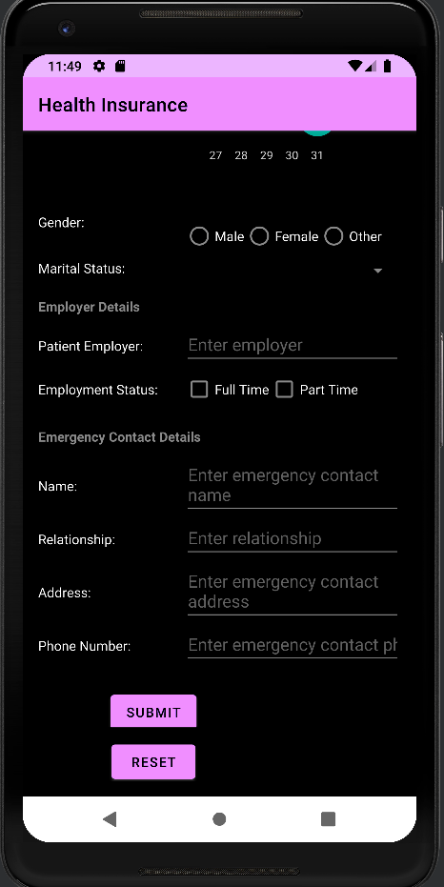

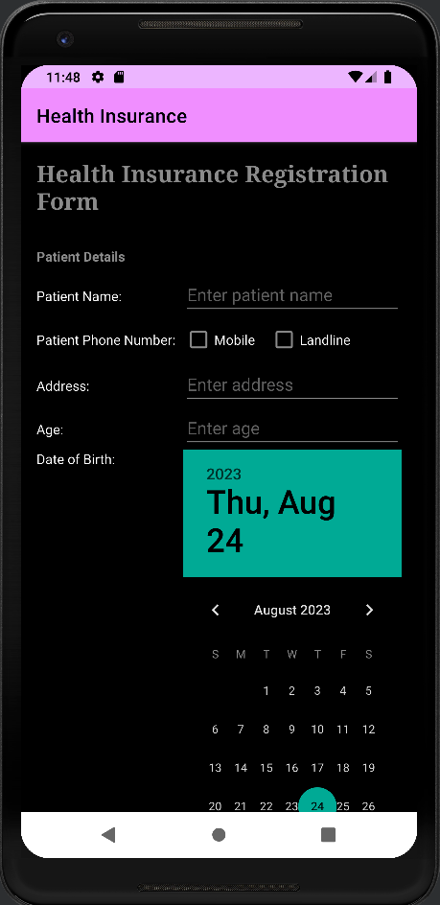

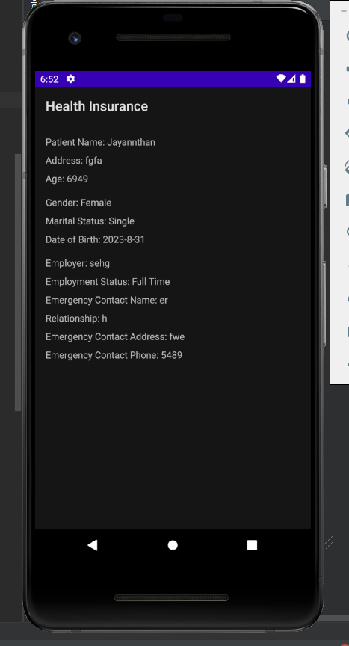

**Result:**

The mobile application was completed successfully

**Best Practices:**

1. Use appropriate variable naming conventions for readability.
2. Implement input validation to ensure data accuracy.
3. Utilize layout resources for UI consistency and responsiveness.
4. Organize the code with comments and logical structure.
5. Implement proper error handling to prevent crashes.

**Learning Outcomes:**

1. Designing Android user interfaces using XML layouts.
2. Data passing between activities.
3. Handling diverse user input elements (text fields, radio buttons, checkboxes, spinners, date pickers).
4. Creating organized layouts with ScrollView, TableLayout, and TableRow.
5. Enhancing Java coding skills for Android development.
6. Managing user interactions and events.